**Microprocessor Lab**

Laboratory Activity No. 2

**Arduino and Tinkercad Interface**

|  |
| --- |
|  |

Score

*Submitted by:*

**Cometa, Leyan Kristoffer P.**

**Saturday (1-4pm) / CPE 0412.1-2**

*Date Submitted*

**30-09-2023**

*Submitted to:*

**Engr. Maria Rizette H. Sayo**

I. Objectives

This laboratory activity aims to implement the principles and techniques of hardware programming using Arduino through:

- creating an Arduino programming and circuit diagram.

II. Method/s

- Perform a task problem given in the presentation.

- Write a code and perform an Arduino circuit diagram of a ring counter that display

eight (8)LEDs starting from left.

III. Results

-This link below is directed to the simulation that was done in the TinkerCad

<https://www.tinkercad.com/things/bKkROCVgAI2-terrific-migelo> blorr/editel?sharecode=8TSg9rgqawPsbnXOG74_idbS72N4CY41hHJ8VSHMrkE

**TinkerCad**

**Exercise 1: Write a code that does a ring counter display for eight (8) LEDs starting from left.**

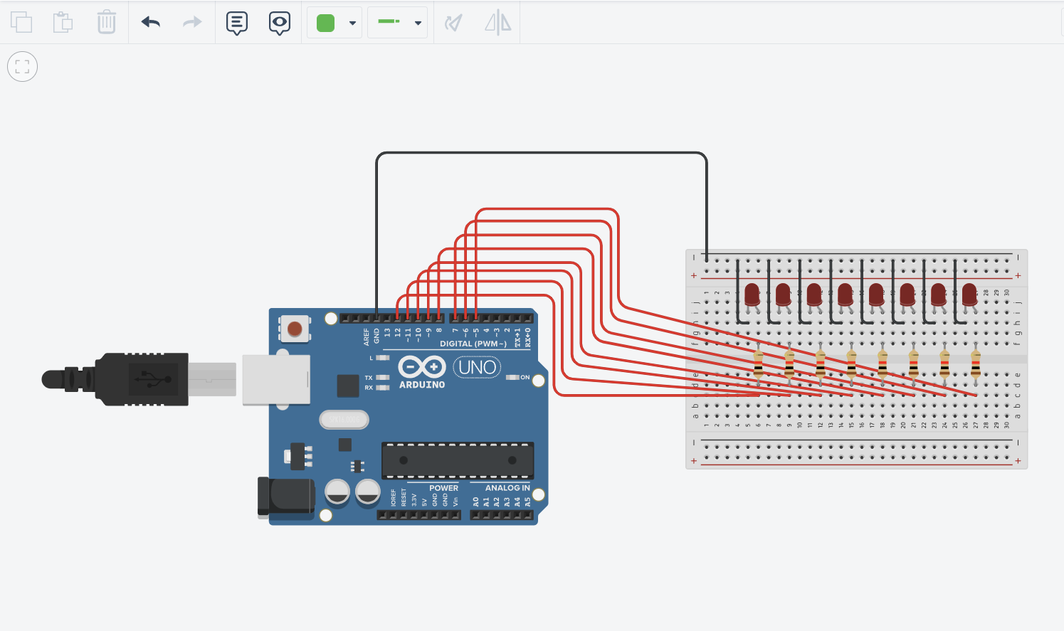

Figure No.1 Ring Counter Display Circuit Diagram

**Components Used**

1. 8 LEDs
2. Resistor
3. Breadboard

**CODE:**

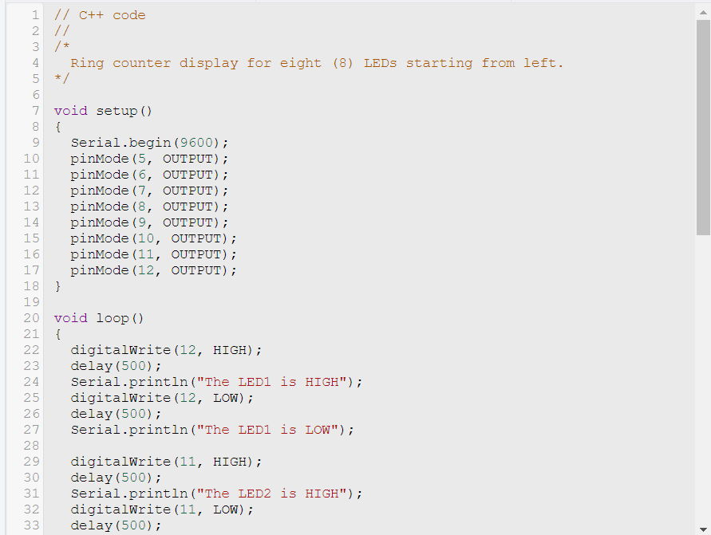

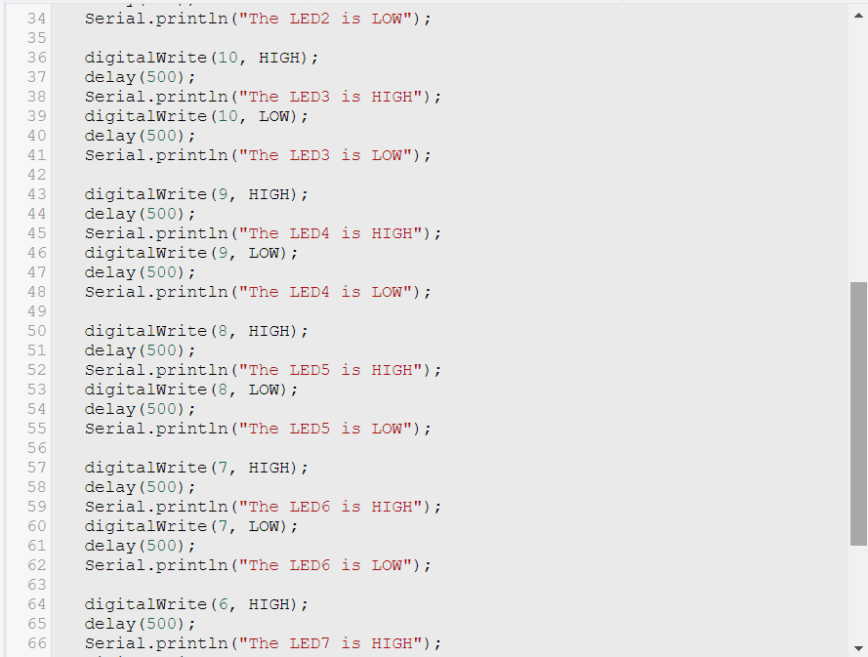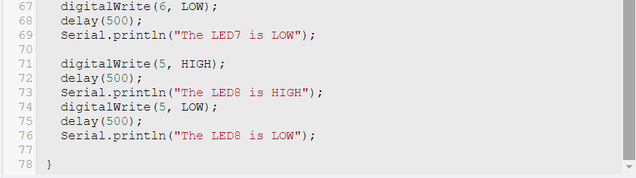

IV. Conclusion

*The conclusion expresses the summary of the whole laboratory report as perceived by the authors of the report.*

There are two elements that must be present when designing a ring counter display: the circuit design and the program. First, a circuit design was created by placing LEDs and resistors on the board. Following that, they were linked to the board's positive and negative terminals, taking into account the pin's pole (negative or positive). The board and its components were linked to the Arduino Uno in order for it to function. The program was then built after the circuitry was completed. In creating a ring counter display, there are two things that must have: circuit design itself as well as the program. Circuit design was made first by putting LED’s and resistors on the board. Afterwards, they’ve been connected to the positive and negative terminal of the board, considering the pin’s value. In order for it to run, the board and its components was connected to the Arduino Uno. After completing the circuitry, the program was created. Within the void setup function, variables were first specified, as well as the pin layout for the LEDs. Following that, in order for the LEDs to light up sequentially from left to right, statements were also arranged in a sequential fashion, beginning with the pin of the LED from the leftmost by using the digital write function. The digital write function takes two parameters: the pin of the LED and the state of the LED, which might be high or low. To make the LEDs light alternately, a delay function with a value of 500 was used, which implies that 500 milliseconds must pass before the second light turns on. Finally, the serial.println function was employed to provide a text representation of the LED

**References**

[1] D.J.D. Sayo. “University of the City of Manila Computer Engineering Department Honor Code,” PLM-CpE Departmental Policies, 2020.

[2] S. I. Sensors, “What is void setup and Void Loop in Arduino,” Simply IoT Sensors | IOT blog, https://www.simplyiotsensors.com/2021/05/Void-setup--Void-loop-in-Arduino.html (accessed Sep. 30, 2023).

[3] How to avoid using the delay() function in Arduino sketches, https://www.digikey.in/en/maker/blogs/2022/how-to-avoid-using-the-delay-function-in-arduino-sketches (accessed Sep. 30, 2023).

[4] “Serial.println(): Arduino reference,” Arduino Getting Started, https://arduinogetstarted.com/reference/serial-println (accessed Sep. 30, 2023).